### NetworkRail_logo

**NATIONAL OPERATIONS CENTRE,**

**FLOOR 3, LOUGHTON,**

**THE QUADRANT MK,**

ELDER GATE,

MILTON KEYNES,

MK9 1EN.

**Tel: 085 65644**

**01908 723644**

**Fax: 08565591**

**01908 723591**

**DAILY INCIDENT REPORT: 0600 TUE 13TH JUNE TO 0600 WED 14TH JUNE 2017**

|  |  |  |
| --- | --- | --- |
| **Duty Controller** | **Support Controller** | **Communications Controller** |
|  |  |  |
| **0700 – 1500 David Burnett** | **0700 – 1500 Cornelius Edjah** | **0700 – 1500 Ian Swain** |
| **1500 – 2300 Bob Scoot** | **1500 – 2300 Matthew Whitfield** | **1500 – 2300 David Stride** |
| **2300 – 0700 Mark Elkin** | **2300 – 0700 David Newton** |  |

|  |  |  |
| --- | --- | --- |
| **NOC - London** |  | **FSDM** |
|  |  |  |
| **0700 – 1500 Kieran Duggan** |  | **0700 – 1400 Clive Elverstone** |
| **1500 – 2300 not covered** |  | **1400 – 2100 Christopher Blunt** |
|  |  | **2100 – 0700 Ivan Stewart** |

|  |
| --- |
| THIS REPORT IS CONFIDENTIAL AND THE CONTENTS MUST NOT BE DIVULGED TO PEOPLE OR ORGANISATIONS OUTSIDE OF THE RAILWAY GROUP |

**To help in identifying locations detailed in this report, each entry now has a prefix to denote in which Route the incident occurred:**

|  |  |  |  |
| --- | --- | --- | --- |
| **A** | Anglia Route | SE-SX | South East - Sussex Route |
| LNE&EM Derby | London North Eastern - East Midlands Route | SE-KT | South East - Kent Route |
| LNE&EM York | London North Eastern - LNE Route | **WN** | Western Route |
| LNWN | London North Western Route - North | WS/CU | Wales / Cymru Route |
| LNWS | London North Western Route - South | WX | Wessex Route |
| Sc | Scotland Route |  |  |

**To help to navigate through incidents, a contents page has been included overleaf. Those who receive this report in electronic format can also click on the heading to step directly to the required section.**

**Table of contents – click on headings to navigate through the report**

[SIGNALLING INCIDENTS 3](#_Toc469549173)

[SIGNALS PASSED AT DANGER 3](#_Toc469549174)

[(CATEGORY ‘A’) 3](#_Toc469549175)

[TRAIN OR VEHICLE RUNAWAY 3](#_Toc469549176)

[STATION OVERRUNS 3](#_Toc469549177)

[STATION OVERRUNS (OPERATING ERROR) 3](#_Toc469549178)

[POWER FAILURES 3](#_Toc469549179)

[POINTS FAILURES 3](#_Toc469549180)

[TRACK CIRCUIT FAILURES 3](#_Toc469549181)

[SIGNALS/SIGNALLING SYSTEMS FAILURES 3](#_Toc469549182)

[BROKEN RAILS/TRACK DEFECTS 3](#_Toc469549183)

[TPWS 4](#_Toc469549184)

[BRIDGE STRIKES 4](#_Toc469549185)

[LEVEL CROSSING INCIDENTS 4](#_Toc469549186)

[ROAD VEHICLE INCURSIONS (NON LEVEL CROSSINGS) 4](#_Toc469549187)

[NEAR MISSES 4](#_Toc469549188)

[DERAILMENTS 5](#_Toc469549189)

[COLLISIONS 5](#_Toc469549190)

[TRAIN DOOR INCIDENTS 5](#_Toc469549191)

[FATALITIES 5](#_Toc469549192)

[STAFF/CONTRACTOR INJURIES/ASSAULTS 5](#_Toc469549193)

[PASSENGER/PUBLIC INJURIES/ASSAULTS 6](#_Toc469549194)

[RAILWAY CRIME 6](#_Toc469549195)

[TRACTION CURRENT PROBLEMS 6](#_Toc469549196)

[WEATHER RELATED PROBLEMS 6](#_Toc469549197)

[FIRES 6](#_Toc469549198)

[IRREGULAR WORKING: NETWORK RAIL OPERATIONS 6](#_Toc469549199)

[IRREGULAR WORKING: NETWORK RAIL INFRASTRUCTURE PROJECTS 6](#_Toc469549200)

[IRREGULAR WORKING: OTHER 6](#_Toc469549201)

[IRREGULAR WORKING: ROUTE SERVICES 7](#_Toc469549202)

[WILD REPORTS & HABD ACTIVATIONS 7](#_Toc469549203)

[MONITORING OF TRAINS 7](#_Toc469549204)

[SIGNIFICANT POSSESSION PROBLEMS 7](#_Toc469549205)

[TRACTION FAILURES (PASSENGER) 8](#_Toc469549206)

[TRACTION FAILURES (NON-PASSENGER) 8](#_Toc469549207)

[GROUP STANDARDS GE/RT8250 & GO/RT3350 8](#_Toc469549208)

[MISCELLANEOUS 8](#_Toc469549210)

[DEREGISTERED VEHICLES/LOCOMOTIVES AND 8](#_Toc469549211)

[OVERLOAD REJECTIONS 8](#_Toc469549212)

[INFORMATION MANAGEMENT PROBLEMS 8](#_Toc469549213)

[REAL TIME PERFORMANCE FIGURES 9](#_Toc469549214)

|  |  |
| --- | --- |
| 01 | SIGNALLING INCIDENTS |

None reported.

|  |  |
| --- | --- |
| 02 | SIGNALS PASSED AT DANGER(CATEGORY ‘A’) |

None reported.

|  |  |
| --- | --- |
| 03 | TRAIN OR VEHICLE RUNAWAY |

None reported.

|  |  |
| --- | --- |
| 04A | STATION OVERRUNS |

None reported.

|  |  |
| --- | --- |
| 04B | STATION OVERRUNS (OPERATING ERROR) |

None reported.

|  |  |
| --- | --- |
| 05A | POWER FAILURES |

None reported.

|  |  |
| --- | --- |
| 05B | POINTS FAILURES |

**(SE-SX)** At 0707 the driver of 9D07, EK, 0703 West Croydon - Highbury & Islington reported that T22 signal on the Up London Bridge Slow line had reverted to red as the train approached. The driver was unable to stop and passed the signal at red by ½ a coach length. S&T attended and confirmed that a download of the data logger revealed that a loss of FMR had caused the reversion.

TRUST 175257 IQBF = 11 trains = 40 mins. Fault No. 132676. CCIL 1590293.

|  |  |
| --- | --- |
| 05C | TRACK CIRCUIT FAILURES |

None reported.

|  |  |
| --- | --- |
| 05D | SIGNALS/SIGNALLING SYSTEMS FAILURES |

**(LNWN)** At 0936 the driver of Metrolink tram 3054, reported that DJ502 signal on the Metrolink line controlled by Network Rail at Deansgate Junction had reverted from green to red as the train approached. The driver was unable to stop and passed the signal at red by an unspecified distance. Metrolink Control confirmed that the reversion was caused by a long standing fault with ‘EA1’ track circuit on the inbound Metrolink line. The driver was fit to continue.

No delay recorded. Fault No. 772117. CCIL 1590372.

|  |  |
| --- | --- |
| 05E | BROKEN RAILS/TRACK DEFECTS |

None reported.

|  |  |
| --- | --- |
| 05F | TPWS |

**(WS/CU)** At 0658 the driver of 1E08, HL, 0600 Carmarthen - Milford Haven, reported that the TPWS Overspeed Sensor had activated on entering platform 1 at Milford Haven whilst travelling at 15 mph with unit 175102. The TPWS Overspeed Sensor is set to intervene at 10.5 mph. An OTMR download was pending at the close of this Report. There was no recorded delay.

CCIL 1590282.

**(LNWN)** At 1228 the driver of 2S33, ED, 1214 Sheffield - Manchester Piccadilly, reported that the TPWS Overspeed Sensor had activated on approach to TE11 signal, which was displaying a red aspect on the Down Hope Valley line at Totley Tunnel East whilst travelling at an unspecified speed with unit 150132. The TPWS Overspeed Sensor is set to intervene at 54 mph. An OTMR download indicated that the train’s speed was 36 mph at the time of the activation.

TRUST 175857 TEDM = 7 trains = 57 mins. CCIL 1590445.

|  |  |
| --- | --- |
| 06 | BRIDGE STRIKES |

|  |  |  |  |  |  |  |  |
| --- | --- | --- | --- | --- | --- | --- | --- |
| **Route** | **Time** | **Location** | **Bridge No.** | **Dispensation** | **NWR** | **CCIL** | **TRUST** |
| WX | 0639 | Esher | 2/58 | DA | 0732 | 1590276 | 175239 XQCW = 18 trains = 77 mins. |
| LNE&EM- Derby | 0749 | Hinckley | WN/6 | R | 0858 | 1590308 | 175440 XQGD = 26 trains = 291 mins. |
| LNE&EM- York | 0755 | Middlesbrough | DSN2/36 | R | 0813 | 1590313 | 175353 XQGL = 3 trains = 9 mins. |
| LNWS | 0910 | Barnt Green | BAG2/112 | DA | 0940 | 1590344 | 175499 XQRB = 7 trains = 47 mins. |
| WS/CU | 0952 | Pennyffordd | WDB1  7m 3ch | R | 1113 | 1590369 | 175551 XQWS = 1 cancelled = 4 part. |
| LNWS | 1158 | Kings Langley | LEC1/74 | DA | 1234 | 1590431 | 175802 XQRA = 64 trains = 488 mins. |

|  |  |
| --- | --- |
| 07 | LEVEL CROSSING INCIDENTS |

**(LNWN)** At 1337 a vehicle failed to stop for the lowering barriers of Bescar Lane AHB LC, between Burscough Bridge and Southport, and struck one of the barriers, damaging one of the boom’s two shear bolts. The Mobile Operations Manager arrived at 1430 and took the crossing under local control. S&T attended and had replaced the bolts by 1515, NWR. The BT Police were advised of the incident (ref.301).

TRUST 176006 XQRM = 2 trains = 13 mins. Fault No. 772146. CCIL 1590470.

|  |  |
| --- | --- |
| 07A | ROAD VEHICLE INCURSIONS (NON LEVEL CROSSINGS) |

None reported.

|  |  |
| --- | --- |
| 08 | NEAR MISSES |

**(WN)** At 1417 the driver of 1M99, EH, 1245 Cardiff Central - Nottingham, reported a very near miss at either Ashchurch No.13 foot crossing, or Ashchurch No.2 foot crossing, between Northway AHB LC and Eckington Loop with a person who attempted to cross as the train approached, forcing the driver to make an emergency brake application. The driver was fit to continue. Following trains were cautioned, with the Mobile Operations Manager and the BT Police (ref. 309) sent to site. NWR at 1430 after the area was reported clear. A further search by police and Network Rail staff utilising the police helicopter was undertaken and concluded by 1541 with nothing amiss found. The Mobile Operations Manager confirmed that both crossings were in order.

TRUST 176035 XQRB = 11 trains = 53 mins. CCIL 1590481.

|  |  |
| --- | --- |
| 08 | NEAR MISSES (cont.) |

**(LNE&EM-York)** At 1817 the driver of 2W86, ED, 1750 Huddersfield – Leeds reported three teenage trespassers at Brighouse. The persons were confirmed to have left the railway by the driver of 1B32, ED, 1718 York Blackpool North at 1854. The driver was fit to continue however at 1955 Northern advised that the driver had deemed the event as a near miss incident.

TRUST 176531 XQGC = 5 trains = 29 mins. CCIL 1590577.

**(LNE&EM-York)** At 1938 the driver of 1E78, EA, 1812 Liverpool Lime Street – Newcastle Central reported a near miss between Ravensthorpe & Dewsbury with four teenagers. The driver was fit to continue to Leeds. The following service through the section was cautioned and its driver confirmed the area was clear and safe for the passage of trains NWR at 1943. The BT Police were advised (ref.559)

TRUST 176691 XQGC = 1 cancelled = 5 trains = 28 mins. CCIL 1590612.

|  |  |
| --- | --- |
| 09 | DERAILMENTS |

None reported.

|  |  |  |  |
| --- | --- | --- | --- |
| **BREAKDOWN & RECOVERY - CRANE STATUS REPORT AT 0200** | | | |
| **CRANE** | **Wigan**  **ADRC 96713, ADB 971002,**  **ADB 975464, ADB 975486.** | **Knottingley**  **\*\*\*ADRC 96714, ADB 971004,**  **ADB**  **975087, ADB 975477** | **Bescot**  **\*ADRC 96710, \*\*\*ADRC 96715**  **\*\*ADB 971001,**  **\*\*ADB 971003, \*\*ADB 975471** |
| **REMARKS** | **All on hand at Wigan.** | **All on hand at Wigan.** | **\*On hand at Wigan**  **\*\*On hand at Bescot.** |

**\*\*\* Remains out of service**

|  |  |
| --- | --- |
| 10 | COLLISIONS |

None reported.

|  |  |
| --- | --- |
| 11 | TRAIN DOOR INCIDENTS |

None reported.

|  |  |
| --- | --- |
| 12 | FATALITIES |

**(LNWN)** At 1338 the driver of 1B21, ED, 1211 Blackpool North – York, reported that the train had struck a person on the Down L&Y line at Eastwood, between Hall Royd Junction and Hebden Bridge. Both lines were blocked, and the emergency services and Network Rail staff attended from 1430. The Route Control, Manchester, advised the NOC at 1343. Dignity Funerals were called at 1345 (NOC ref. 4203) and gave an ETA of 1445. The BT Police (ref. 282) reported at 1353 that having obtained a statement from the driver, they had deemed the incident a non-suspicious act. Dignity Funerals arrived on site at 1440. Site investigations were completed, the body removed and the adjacent Up L&Y line reopened at 1445. The Down L&Y reopened once 1B21 continued forward, at 1520. The site was checked by the Mobile Operations Manager and Samaritans signage / anti-trespass measures were found not to be in place at the location.

TRUST 175980 XQGC = 7 cancelled = 13 part = 109 trains = 1086 mins.

CCIL 1590474.

|  |  |
| --- | --- |
| 13 | STAFF/CONTRACTOR INJURIES/ASSAULTS |

None reported.

|  |  |
| --- | --- |
| 14 | PASSENGER/PUBLIC INJURIES/ASSAULTS |

None reported.

|  |  |
| --- | --- |
| 15 | RAILWAY CRIME |

None reported.

|  |  |
| --- | --- |
| 16 | TRACTION CURRENT PROBLEMS |

None reported.

|  |  |
| --- | --- |
| 17 | WEATHER RELATED PROBLEMS |

None reported.

|  |  |
| --- | --- |
| 18 | FIRES |

None reported.

|  |  |
| --- | --- |
| 19A | IRREGULAR WORKING: NETWORK RAIL OPERATIONS |

None reported.

|  |  |
| --- | --- |
| 19B | IRREGULAR WORKING: NETWORK RAIL INFRASTRUCTURE PROJECTS |

None reported.

|  |  |
| --- | --- |
| 19C | IRREGULAR WORKING: OTHER |

**(SE-KT)** At 1746 the driver of 1F55, HU, 1726 Faversham - London St. Pancras, formed by units 395015 & 395004, comprising 12 coaches in all, brought the train to a stand at the six car marker board at Rainham and released all doors on the train. Upon realising the error, all doors were re-secured. There were no passenger incidents reported. The service was terminated and sent ECS to London St. Pancras, with the Driver Manager arranged to meet the driver on return to Ashford.

TRUST 176489 THUE = 1 part cancelled = 5 trains = 40 mins. CCIL 1590572.

**(Sc)** At 1548 the driver of 2H46, HA, 1526 Helensburgh Central - Edinburgh Waverley, formed by units 334028 & 334002 comprising six coaches in all, brought the train to a stand at the three car marker board at Dalreoch station, and released all doors on the train. Upon realising the error, all doors were closed and the train moved forward into the platform. The driver continued to Airdrie before being relieved, as per the their diagram. 2H46 continued to destination.

TRUST 176199 THAY = 8 trains = 27 mins. CCIL 1590517.

**(LNE&EM-York)** At 1820 the driver of 1P94, ET, 1737 London King’s Cross - Peterborough formed by units 365513, 365509 and 365533 comprising 12 coaches in all, brought the train to a stand on platform 1 at St Neots station and opened the doors of the service with three doors of the rear unit not accommodated the station’s platform. The driver did not disclose the incident to the signaller and the Route Control were not advised by Govia Thameslink Railway until 1848. The driver was met on arrival at Peterborough by a Govia Train Manager.

CCIL 1590602.

|  |  |
| --- | --- |
| 19D | IRREGULAR WORKING: ROUTE SERVICES |

None reported.

|  |  |
| --- | --- |
| 20 | WILD REPORTS & HABD ACTIVATIONS |

**(WN)** At 0102 6M38, WA, 2338 Southampton Eastern Docks - Halewood, activated Cholsey Down Main line WheelChex/Gotcha system with axle 17 RHS wheel flat, 368kN, level 3 alarm. The train was stopped and the driver advised to proceed at 40 mph to Bescot for RST examination. The vehicle, IPA 874380437, as per consist, was taken out of traffic.

TRUST 177240 MWAW = 1 train = 9 mins. CCIL 1590718.

**HABD Non confirmed Reports**

|  |  |  |  |  |  |
| --- | --- | --- | --- | --- | --- |
| **Route** | **Time** | **HABD Location** | **Train** | **Result** | **CCIL** |
| None |  |  | None |  | None |

**This is a list of currently Disconnected Hot Axle Box Detectors**

|  |  |  |  |  |  |  |  |  |  |
| --- | --- | --- | --- | --- | --- | --- | --- | --- | --- |
| Route | Location | Line | Date  Disconnected | Reason | TOC’s/ FOC’s advised | Planned Restoration Date | Date Restored | Function | Fault Number |
| Anglia | Brentwood | Down Electric | 10/03/16 | Offline | Y | Awaiting update |  | IM | 234632 |
| Anglia | Brentwood | Down Main | 10/03/16 | Offline | Y | Awaiting update |  | IM | 234632 |
| LNE&EM North | Chevington | Up Fast/Main | 31/12/16 | Not recording correctly | Y | 01/07/2017 |  | IM | 654298 |
| LNE&EM North | Newham | Up Main | 16/12/16 | Defective | Y | 31/08/2017 |  | IM | 625121 |
| LNE&EM North | Stamford | Down Main | 04/02/17 | Failed auto test | Y | 15/07/2017 |  | IM | 658379 |
| LNE&EM North | Thorne South | Down Main | 27/01/17 | Inductive Counting Switch Error | Y | 10/07/2017 |  | IM | 657563 |
| LNWS | Soulbury Road | Down Fast | 09/12 | Awaiting relocation | Y | Awaiting update |  | IP |  |
| LNWS | Soulbury Road | Down Slow | 18/09/10 | Signallers display to be updated / risk assessment | Y | Awaiting update |  | IP |  |
| LNWS | Castlethorpe | Up Fast | 19/04/17 | HOAL shutter failure | Y | 16/06/2017 |  | IM |  |
| LNWN | Low Mill | Down Main | 26/11/14 | Awaiting replacement | Y | 08/09/17 |  | IP | 671852 |
| WN | Basildon | Up Main | 20/04/17 | Mirrors need cleaning | Y | 23/06/2017 |  | IM | 383441 |
| WN | Filton | Up Main | 28/12/16 | Telecoms Fault | Y | Awaiting update |  | IP | 378942 |
| WN | Maidenhead | Up Main | 12/05/17 | Defective | Y | Awaiting update |  | IM | 387815 |
| WN | Studley | Up Main | 16/05/16 | Required moving due to flooding | Y | Awaiting update |  | IM | 362543 |

|  |  |
| --- | --- |
| 21 | MONITORING OF TRAINS |

None reported.

|  |  |
| --- | --- |
| 22 | SIGNIFICANT POSSESSION PROBLEMS |

None reported.

|  |  |
| --- | --- |
| 23A | TRACTION FAILURES (PASSENGER) |

**(LNE&EM-York)** At 0822 the driver of 1A15, HB, 0734 Harrogate - London King’s Cross formed by HST set EC56 with power cars 43295 & 43311, reported that the train had come to a stand on the Up Doncaster line at Holbeck Junction owing to loss of power. They further indicated that the rear power car had shut down and the front power car had a WSP defect, and as such it was unable to move forward up the gradient of the Copley Bank ahead. The train was declared a failure at 0917 and an assisting locomotive was sought and dispatched from Doncaster. The assisting locomotive made a wrong directional movement over the Up Doncaster line from Wakefield Westgate and arrived on site at 1008. 1A15 was on the move at 1029, 130 minutes late to Wakefield Westgate with assistance, where passengers were detrained, before running as ECS via Holbeck Junction to Neville Hill T&RSMD.

TRUST 175277 MHBD = 10 cancelled = 10 part = 162 trains = 1818 mins.

CCIL 1590330.

|  |  |
| --- | --- |
| 23B | TRACTION FAILURES (NON-PASSENGER) |

None reported.

|  |  |
| --- | --- |
| 24 | GROUP STANDARDS GE/RT8250 & GO/RT3350 |
|  | To notify the National Operations Centre of an Urgent Operating Advice then please use the NIR 3350 electronic template found on the RSSB website [www.railnotices.net](http://www.railnotices.net). The instructions for completion and submission of these notices are on the Rail Notices site. |

None reported.

|  |  |
| --- | --- |
| 25 | MISCELLANEOUS |

**(WN)** At 0001 (Tue) South Wales Signalling Centre advised Gloucester PSB that sparks had been reported emanating from the rear of 6E20, WA, 2306 (Mon) Llanwern - Immingham SS. The train was brought to a stand on the Up Main line on approach to Ley CCTV LC, between Lydney and Gloucester. The driver examined the train, and reported at 0021 (Tue) that the handbrake was on, on the leading bogie of the rear vehicle, BYA 966211. The driver advised that the wheelset was damage, but appeared fit for 20 mph. P’Way staff and a Mobile Operations Manager were on site at 0200 (Tue). DB Cargo arranged for technical staff to attend from Avonmouth, who arrived at 0220 (Tue). At 0300 (Tue) it was reported that the train was fit to proceed at 10 mph, for six miles to Gloucester where the affected wagon could be removed. P’Way staff reported at 0304 (Tue) that no rail damage had been found. The train moved off at 0336 (Tue), but it transpired that the train could travel no faster than walking pace, arriving into Gloucester at 0627 where the defective vehicle was detached.

TRUST 174867 MWAM = 4 part = 3 trains = 29 mins. Fault No.390114. CCIL 1590191.

|  |  |
| --- | --- |
| 26 | DEREGISTERED VEHICLES/LOCOMOTIVES ANDOVERLOAD REJECTIONS |

None reported.

|  |  |
| --- | --- |
| 27 | INFORMATION MANAGEMENT PROBLEMS |

None reported.

|  |  |
| --- | --- |
| 28 | REAL TIME PERFORMANCE FIGURES |

Real Time Performance Figures at conclusion of daily service:

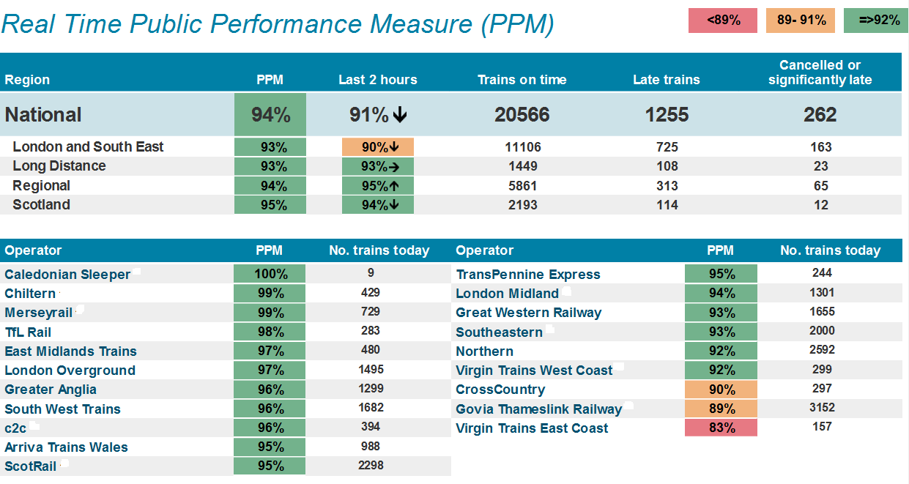



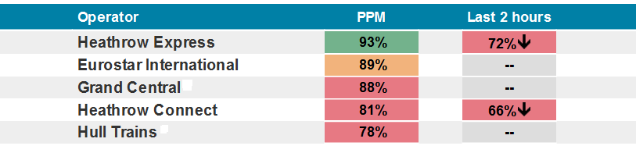

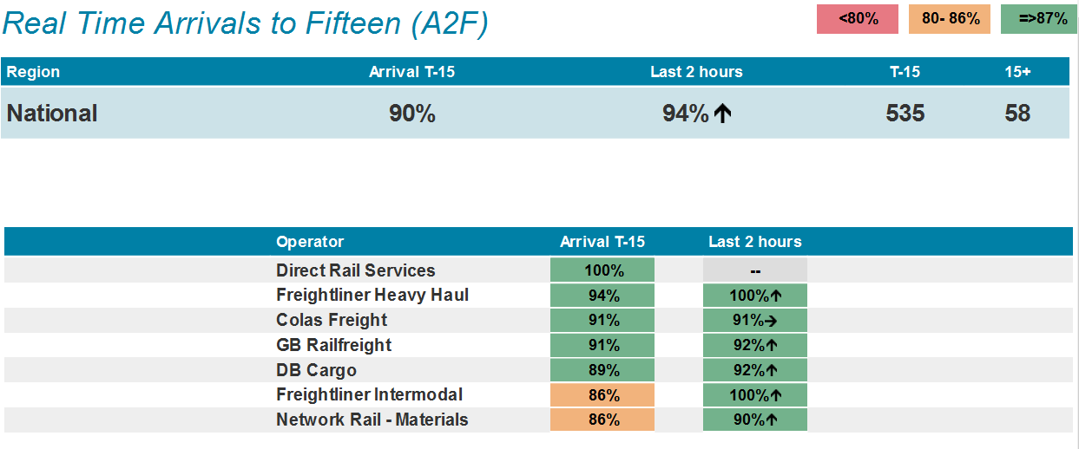

**END.**